EX. NO: | ONLINE MCQ QUIZ APPLICATION USING REACT JS AND NODE JS
DATE: | ONLINE MCQ QUIZ APPLICATION USING REACT JS AND NODE JS

AIM:
To build an online MCQ quiz application using React JS and Node JS where questions and options are fetched from a NodeJS server based on the selected topic.

ALGORITHM:

STEP 1: Create a React JS project for frontend and Node JS project for backend.
STEP 2: Create a NodeJS server using Express.
STEP 3: Store quiz questions for different topics in an array.
STEP 4: Create an API endpoint to send questions based on selected topic.
STEP 5: Create React components for topic selection and question display.
STEP 6: Use useState() and useEffect() in React.
STEP 7: Fetch questions from NodeJS server using fetch().
STEP 8: Display questions and options dynamically.
STEP 9: Allow users to select answers and calculate score.
STEP 10: Display final result.

PROGRAM CODE:

Backend (server.js)
const express = require("express");
const cors = require("cors");

const app = express();

app.use(cors());

const quizData = {
Java: [
{
question: "Java is a ?",
options: [
"Programming Language",
"Database",
"Operating System",
"Compiler"
]
},
{
question: "JVM stands for ?",
options: [
"Java Virtual Machine",
"Java Variable Method",
"Joint Virtual Method",
"Java Version Model"
]
}
],

React: [
{
question: "React is a ?",
options: [
"Library",
"Database",
"Framework",
"Server"
]
},
{
question: "Hook used for state?",
options: [
"useState",
"useEffect",
"useRoute",
"useApp"
]
}
]
};

app.get("/quiz/:topic", (req, res) => {
const topic = req.params.topic;
res.json(quizData[topic] || []);
});

app.listen(5000, () => {
console.log("Server running on port 5000");
});

Frontend (App.jsx)
import { useState } from "react";
import "./App.css";

function App() {
const [topic, setTopic] = useState("");
const [questions, setQuestions] = useState([]);

const fetchQuiz = async (selectedTopic) => {
setTopic(selectedTopic);

const response = await fetch(
`http://localhost:5000/quiz/${selectedTopic}`
);

const data = await response.json();

setQuestions(data);
};

return (
<div className="container">
<div className="quiz-box">
<h1>MCQ Quiz App</h1>

<button onClick={() => fetchQuiz("Java")}>
Java
</button>

<button onClick={() => fetchQuiz("React")}>
React
</button>

{questions.map((q, index) => (
<div className="question-card" key={index}>
<h3>
{index + 1}. {q.question}
</h3>

{q.options.map((option, i) => (
<p key={i}>
<input
type="radio"
name={index}
/>
{option}
</p>
))}
</div>
))}
</div>
</div>
);
}

export default App;

app.css
body {
font-family: Arial, sans-serif;
background: linear-gradient(135deg,#4facfe,#00f2fe);
}

.container {
display: flex;
justify-content: center;
padding: 40px;
}

.quiz-box {
width: 600px;
background: white;
padding: 30px;
border-radius: 15px;
}

button {
margin: 10px;
padding: 12px;
border: none;
background: #4facfe;
color: white;
border-radius: 10px;
}

.question-card {
margin-top: 20px;
padding: 15px;
background: #f2f2f2;
border-radius: 10px;
}

main.jsx
import { StrictMode } from 'react'
import { createRoot } from 'react-dom/client'
import './index.css'
import App from './App.jsx'

createRoot(document.getElementById('root')).render(
<StrictMode>
<App />
</StrictMode>,
)

OUTPUT:
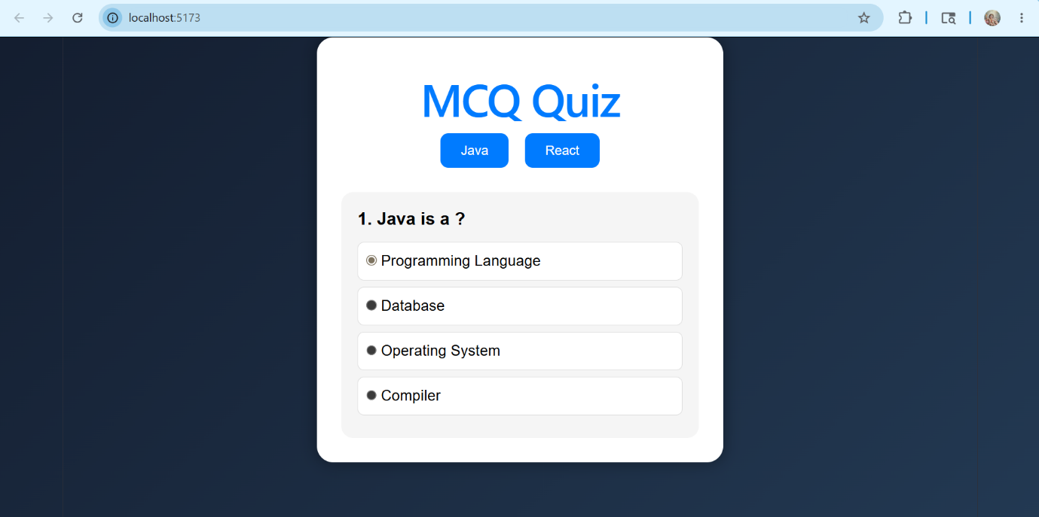

RESULT:
Thus, the online MCQ quiz application was developed successfully using React JS and Node JS, where questions and options are fetched dynamically based on the selected topic.

